Output:

**Output-1:**

**Login Account:**

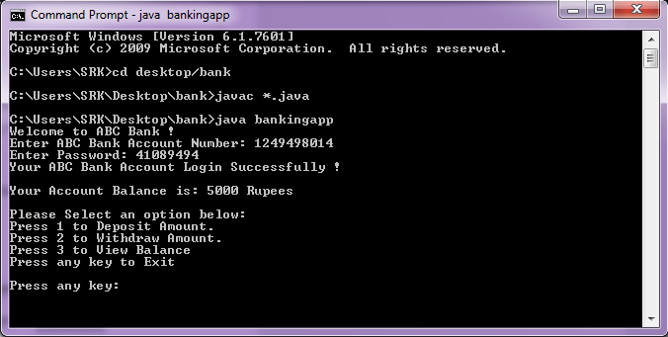

### Output-2:

**Deposit:**

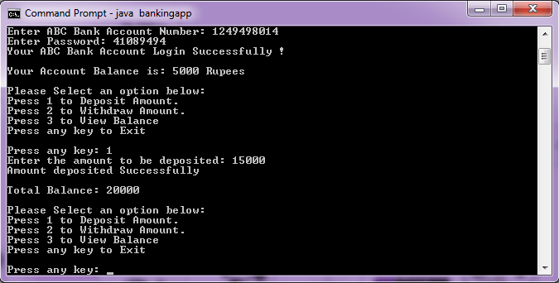

### Output-3:

**Withdraw:**

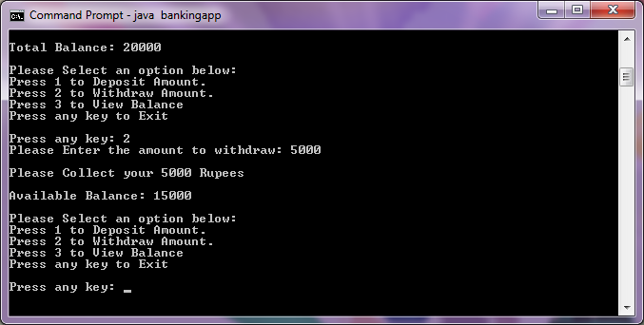

### Output-4:

**View Balance & Logout Account:**

